Name: Aditya Kangune

Roll No: 23365

Class: SE-11

Batch: G-11

**________________________________________________________________ Assignment: 4**

**AIM:**

• Design & Develop DB for “Order Management System” with all the  constraints

**PROBLEM STATEMENT / DEFINITION:**

• Design & Develop DB for “Order Management System” with all the constraints.  (There must be At least 3 entities and relationships between them.)

• The statement should use SQL objects such as Table, View, Index, and Sequence. Draw suitable ER/EER diagram for the system.

**OBJECTIVE:**

1. To understand the concept of ER diagram.

2. To understand the details of basic ER model

3. Analyze the reflected relationship and constraints

**THEORY:**

**Basic concepts of ER Diagram:**

A database can be modeled as a collection of entities and relationship among Entities. Entity:  entity is an object that exists and is distinguishable from other objects. Example: specific  person, company, event, plant

**Entity set**: An entity set is a set of entities of the same type that share the same properties.  Example: set of all persons, companies, trees, holidays

**Attributes**: Entities have attributes Example: people have names and

addresses Attribute types:

1 Simple: e.g. roll no

2 Composite attributes: e.g. name, address

3 Single-valued: roll no

4 Multi-valued attributes: e.g. Phone-numbers

5 Derived attributes: Can be computed from other attributes

E.g. age, given date of birth

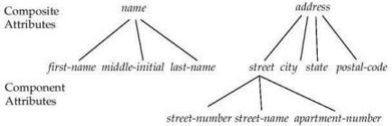

**Relationship**: A relationship is an association among several entities Example:  Hayes depositor A-102customer entity relationship set account entity

**Relationship set**: A relationship set is a mathematical relation among n ≥ 2 entities,  each taken from entity sets

{(e1, e2, en) | e1 ε E1, e2 ε E2, en ε En} where (e1, e2, en) is a relationship Example: (Hayes, A-102) ε depositor

**Mapping Cardinalities:**

Express the number of entities to which another entity can be associated via a relationship set.  Most useful in describing binary relationship sets. For a binary relationship set the mapping  cardinality must be one of the following types:

1. One to one

2. One to many

3. Many to one

4. Many to many

**Symbolic notations:**

Components to draw entity relationship diagram.

**Rectangles**: represent entity sets.

**Diamonds**: represent relationship sets.

**Lines**: link attributes to entity sets and entity sets to relationship sets.

**Ellipses**: represent attributes

**Double ellipses**: represent multivalued attributes.

**Dashed ellipses**: denote derived attributes.

**Underline**: indicates primary key attributes (will study later)

**Extended ER Features:**

**Specialization**

Top-down design process; we designate sub groupings within an entity set that are distinctive  from other entities in the set. These sub groupings become lower-level entity sets that have  attributes or participate in relationships that do not apply to the higher level entity set.  Depicted by a triangle component labeled ISA (E.g. customer “is a” person).

**Attribute inheritance** – a lower-level entity set inherits all the attributes and relationship  participation of the higher-level entity set to which it is linked

1) To convert an ER Diagram into Database tables.

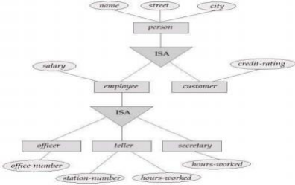

**Generalization**

A bottom-up design process – combine a number of entities sets that share the same features  into a higher-level entity set. Specialization and generalization are simple inversions of each  other; they are represented in an E-R diagram in the same way. The terms specialization and  generalization are used interchangeably.

**Aggregation**

Consider the ternary relationship works-on, which we saw earlier. Suppose we want to record  managers for tasks performed by an employee at a branch Relationship sets works on and  manages to represent overlapping information. Every managed relationship corresponds to a  works-on relationship However, some works-on relationships may not correspond to any  managed relationships. So we can’t discard the work-on relationship.

Eliminate this redundancy via aggregation. Treat relationships as an abstract entity. Allows  relationships between relationships. Abstraction of relationship into new entity without  introducing redundancy, the following diagram represents:

An employee works on a particular job at a particular branch. An employee, branch, and job  combination may have an associated manager.

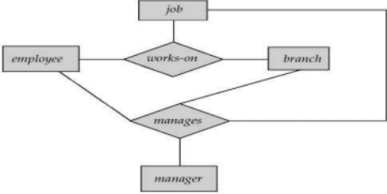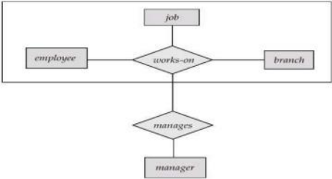

4) Example: E-R Diagram for Bank organization

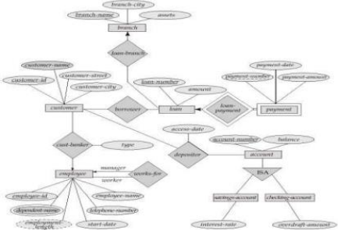**Implementation**:-

**E-R Diagram for**

1. Order Management System

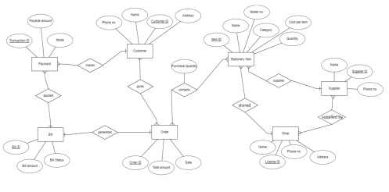

2. Practice E-R Diagram Statement

**CONCLUSION**:

We learned about ER Diagrams and how to design relational database system models.